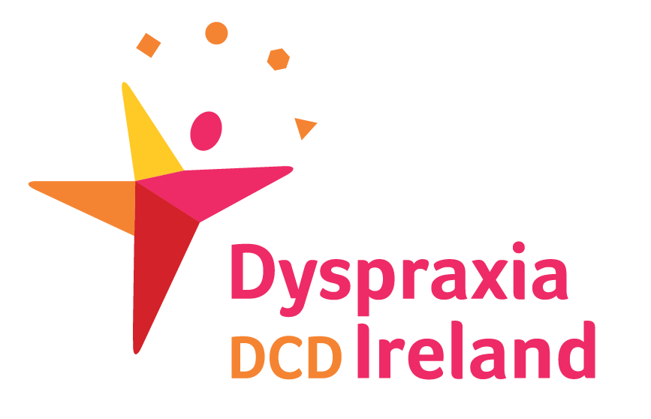
Tuesday July 3rd 2018

‘Partnering for Change’
an innovative model that transforms health service provision for school-aged children with developmental coordination disorder.

Dyspraxia DCD Ireland are honoured to host an evening talk plus Q & A by Prof. Cheryl Missiuna for researchers, clinicians ,health professional students, educators and parents The purpose of the first talk is to familiarize clinicians, parents and researchers with Partnering for Change which is a population-based approach to management of children with DCD/dyspraxia. We do not emphasise diagnosis but rather encourage support for participation in school, in leisure and community activities.

Weds am July 4th 2018

For researchers , clinicians and physicians.
There will be an informal conversation/discussion/answering questions .If people coming had questions, thoughts, ways of approaching partnering to change to a more inclusive education system that would be helpful.

Cheryl Missiuna, PhD, OTReg(Ont) is a Professor in the School of Rehabilitation Science, a Scientist with CanChild and the Infant and Child Health (InCH) Lab, and holder of the John and Margaret Lillie Chair in Childhood Disability Research
Ashling Hotel,Parkgate Street,Dublin 8.
Tuesday July 3rd 2018 . 7.30 – 9.30 pm Tickets : €25
Weds July 4th 2018 10.00 am – 12.00 pm Tickets : €25
Book online and more information on www.dyspraxia.ie or phone Dyspraxia DCD Ireland 01-8747085

